1) Write an assembly language code to derive the final value of the number sequence 1+2+3+4+…..+N. (Using Loop). Take the input value of N (in between 2 to 9) as a single ASCII character and then adjust it to the actual decimal value in your program. Finally, store the output in a variable named RESULT. You do not need to display the output in the console.

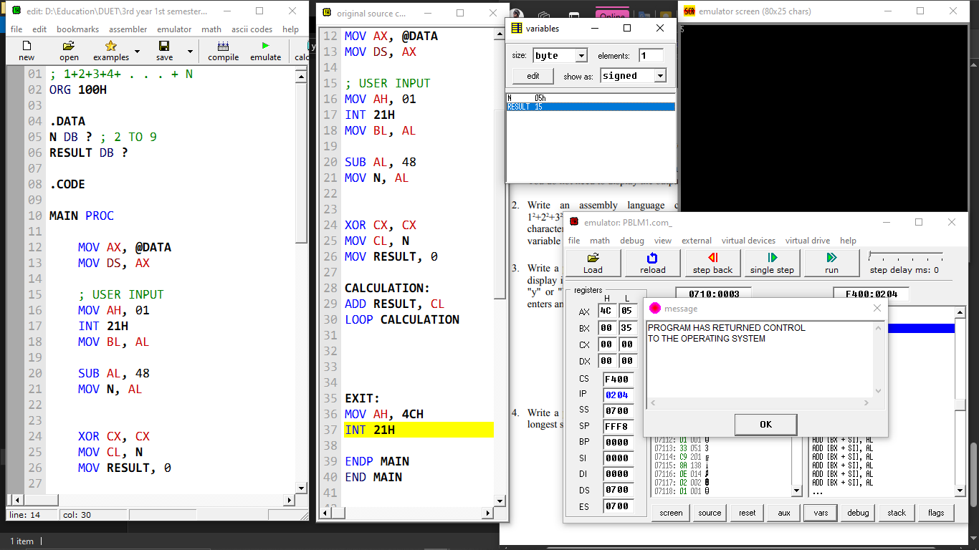

2) Write an assembly language code to derive the final value of the number sequence 1 2+22+32+42+…..+N2 . (Using Loop). Take the input value of N (in between 2 to 9) as a single ASCII character and then adjust it to the actual decimal value in your program. Finally, store the output in a variable named RESULT. You do not need to display the output in the console.

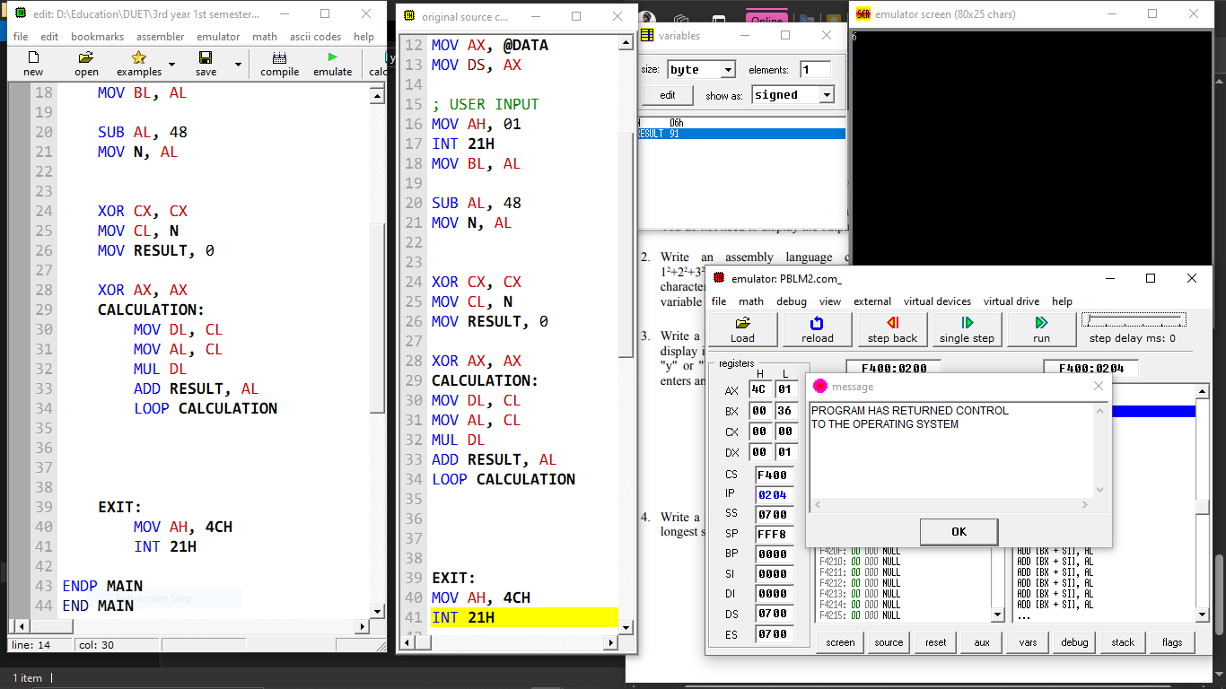

3) Write a program that will prompt the user to enter a hex digit character ("0"· ... "9" or "A" ... "F"), display it on the next line in decimal, and ask the user if he or she wants to do it again. If the user types "y" or "Y", the program repeats; If the user types anything else, the program terminates. If the user enters an illegal character, prompt the user to try again.

ENTER A HEX DIGIT: 9

IN DECIMAL IS IT 9

DO YOU WANT TO DO IT AGAIN? y

ENTER A HEX DIGIT: c

ILLEGAL CHARACTER - ENTER 0 .. 9 OR A .. F: C

IN DECIMAL IT IS 12

DO YOU WANT TO DO IT AGAIN? N

